**PROJECT DESIGN PHASE 1 – SOLUTION ARCHITECTURE**

Date-28/10/2022 Team Id: PNT2022TMID49788

Project Name: Gas Leakage monitoring & Alerting system for Industries

Maximum Marks:4 marks

Alerting people by notifying in mobile apps.

Fire is sensed through fire sensor

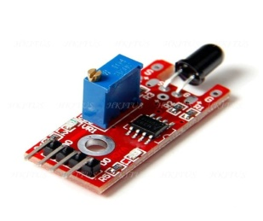

If leaked gas catches fire due to environment



Messaging fire service in case of firing

Cloud stores the atmospheric gas values sensed by MQ.

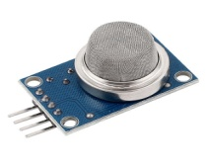

Alerting is done by Alexa Communication service.

Alerting public places

If the values are more than the programmed value(i.e dangerous for atmosphere) Alarm and led glows for alerting

Gas Sensor

Micro-Controller